 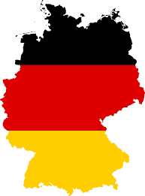 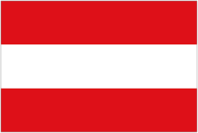

**SPRECHEN *SIE* DEUTSCH?**

Do *you* speak German?

**German Conversation**

**at Beccles Library**

**Tuesday 8th & 22nd August 2017**

**2.00 – 4.00pm.**

Come and join us for German conversation **on the second and fourth Tuesday of each month** at Beccles Library.

If you have some previous knowledge of conversational German,

from elementary to native level, we would love to see you.

(NB: the group is not suitable for complete beginners).

***For further details please contact Chris Greenhill 01502 715733.***